SUBTITLE DISPLAY

Proof of Concept

Proposed by eSpark

Introduction
This report provides a solution for displaying subtitles on screen. Data is sent via Bluetooth from mobile application to a server, which then forwards it to individual devices via Wi-Fi that display it on a screen.
Block Diagram
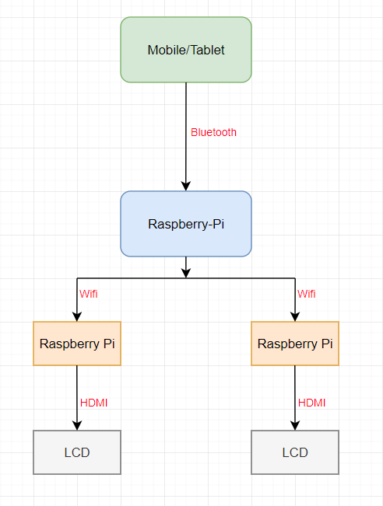

Working Methodology
- After having a connection between mobile/tablet and server via Bluetooth, user will send data that needs to be displayed.
- The server receives data and simultaneously forwards it to the client devices via Wi-Fi.
- Client device will display the subtitles on LCD.

Component Selection

- Development Board
For Development board, we have a lot of options from different companies. Most famous ones available are
- Jetson Nano
- Raspberry Pi
- Orange Pi
Among all, Raspberry Pi is most suitable because of community support available online. It has a strong Processor that is suitable for the application.

- LCD

Selected by Client

Cost
3 * Raspberry Pi (Server = 1, Client = 2)
2 * LCD

Component | Quantity | Unit Price ($) | Shipping ($) | Total ($)
Raspberry Pi | 3 | 72 | 78 | 294
LCD | 2 | 120 | 50 | 290
Total Cost |  |  |  | 584

